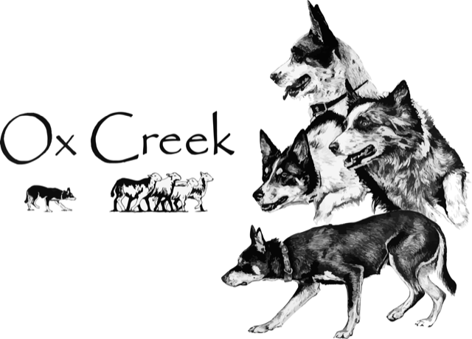
Open & Novice Trial
Judge: Sergio Perello
September 14-15, 2024 USBCHA Open and Nursery
September 16, 2024 NEBCA NN, PN, Ranch

Information: Entries open 8/1/24 and close on 8/15/24. Cancellations with a full refund will be accepted until the end of the day 8/15/24. The running order will be drawn and posted the week before the trial.
Entry fees: $70 for Open, $45 for Nursery, $50 for NN, PN and Ranch. Please send a separate check for 3rd Open dogs. Contact Carolyn at 860-729-0550 (texts preferred) or tobyfwest@gmail.com with questions.
Camping: Camping space will be provided at Finger Lakes Equestrian Center, 5275 Parrish St Ext, Canandaigua, NY 14424. Use main farm entrance, and turn left around the east end of the barn. There are no hook-ups. Bring water for your personal use. Please remember this is a working horse farm and keep your speed under 10 mph, especially while passing the indoor riding ring. This is a working farm.
Local lodging establishments:
- Super 8, 4450 Eastern Blvd, Rtes. 5/20/332, Canandaigua, NY 14424, 800-536-1211
- Holiday Inn Express, 4420 Eastern Blvd, Rtes. 5/20, Canandaigua, NY 14424, 877-859-5095
- Budget Inn, 6001 State Route 96, Farmington, NY 14425-8914, 585-924-5020
- Finger Lakes Hotel, 6108 Loomis Rd, Farmington, NY 14425-9529, 585-398-7693

Food: We will have a food vendor (breakfast/lunch) and there are a number of eateries within 5 miles.
Directions: The trial will be held at 5275 Parrish St Ext, Canandaigua, NY 14424. Contact Paul Batz if you need help navigating oxcreek78@gmail.com 585.298.0789 (texts preferred)

Ox Creek Open & Novice Sheep Dog Trial Entry Form
September 14-16, 2024
Handlers Name:___________________________________________________
Address:_________________________________________________________
Phone:______________ Email:____________________________
Open $70, Nursery $45, NN, PN and Ranch $50
Open & Nursery - Sat/Sun September 14-15
Dog | Open 1 | Open 2 | Nursery 1 | Nursery 2 | Total
NN, PN, Ranch - Mon, September 16
Dog | NN | PN | Ranch | Total
Total:________
Make Checks Payable in USD to: Ox Creek
Mail entries to: Carolyn West, 105 Lynbrook Rd, Paoli, PA 19301
Contact Carolyn for any questions tobyfwest@gmail.com or 860-729-0550

ALL HANDLERS MUST SIGN IN AGREEMENT TO THE FOLLOWING:
I assume all risks to self, dog(s), dependents and property while involved in any way with this trial. I agree to hold harmless NEBCA Inc., Ox Creek LLC, Finger Lakes Equestrian Center LLC, Canandaigua Lake Farm LLC, trial managers, trial committee, trial volunteers, judge and any and all others involved in this trial in any way. Furthermore, I agree to pay for any damage to persons, animals or property caused by me, my dog(s), or my dependents while involved in this trial. I understand that the trial managers will enforce safe and mannerly behavior and sportsmanlike conduct throughout the trial. Those in violation will be asked to leave without a refund. Additionally I fully understand and take full responsibility that attending this event may put me and my family at risk for exposure to COVID 19 and will not hold any party associated with the event responsible in any way. I will also take as many precautions as required by trial managers to aid in the preventable spread of COVID-19.

Signature: ________________________________________ Date: ________________

